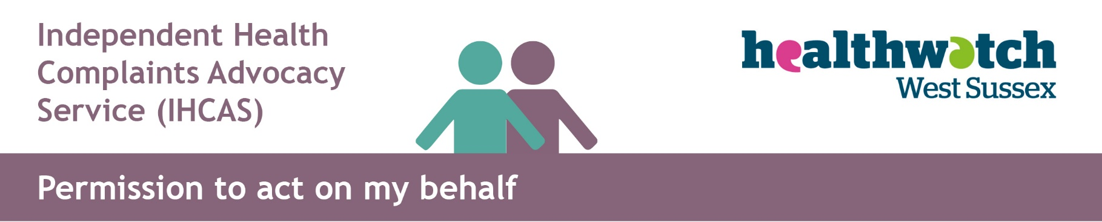

Consent Form
I, (patient’s name) ___________________________________ of (address):

_____________________________________________________________________________.

Please tick one option:

☐ I do authorise IHCAS West Sussex and my parent(s)/Legal guardian(s) and or ____________________________to act on my behalf and I give my permission for the release of the relevant personal details which relate to my complaint(s)/concern(s).

Therefore, I am confirming that:
- I am aware access to personal information or records may be required for the matter to be investigated and responded to.
- Permission is given to IHCAS Healthwatch West Sussex to liaise with relevant external agencies.
OR
☐ I do not authorise _____________________________ to act on my behalf and I will not give my permission for the release of personal details.

Signed ___________________________________ Date ________________

You can withdraw your consent at any time by calling the IHCAS Team on 0300 012 0122, by emailing ihcas@healthwatchwestsussex.co.uk or writing to the address below.

Please return completed form as soon as possible to avoid delay to:
Emailed to: ihcas@healthwatchwestsussex.co.uk or posted to Healthwatch West Sussex, PO Box 1360, Crawley, West Sussex, RH10 0QS

